Banking Transaction UMLs

- ER Relationship

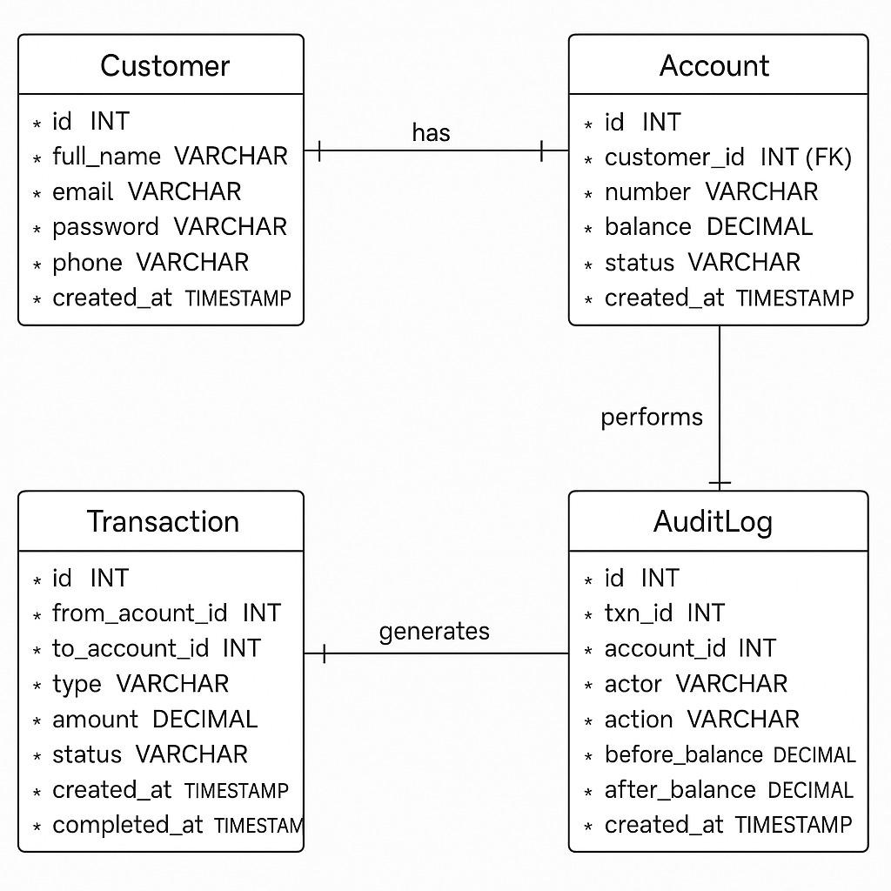

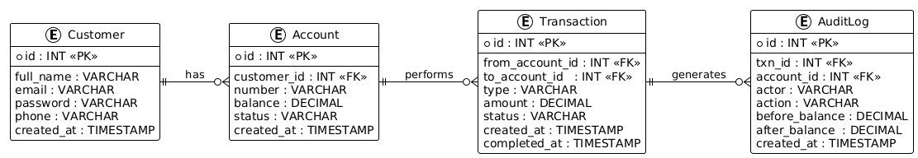

- Class Diagram

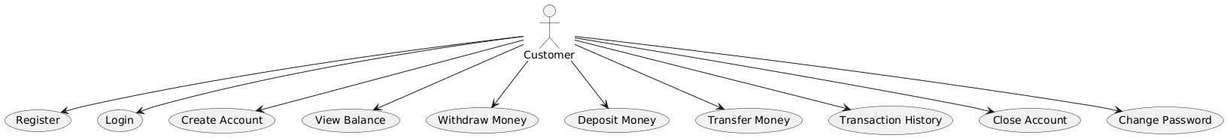

- Use Case Diagram
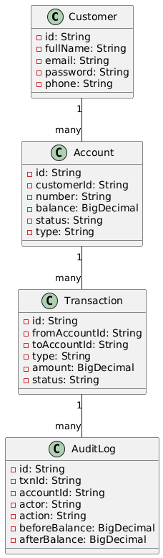
- Register Activity Diagram

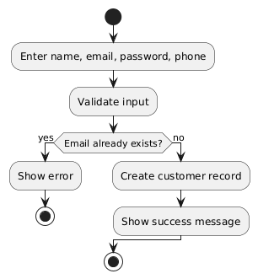

- Login Activity Diagram

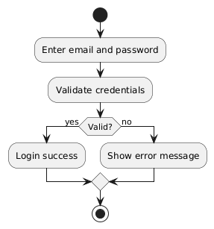

6.Create Account Activity Diagram

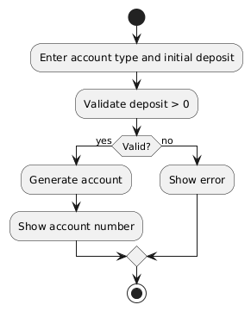

7.View Balance Activity Diagram

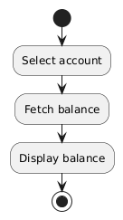

8. Withdraw Money Activity Diagram

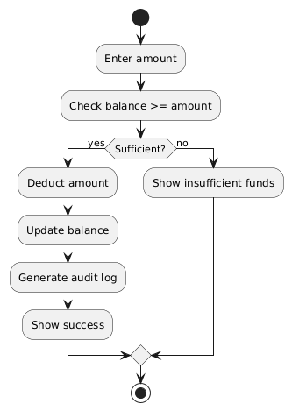

9. Deposit Money Activity Diagram

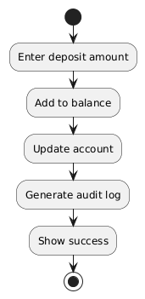

10. Transfer Money Activity Diagram

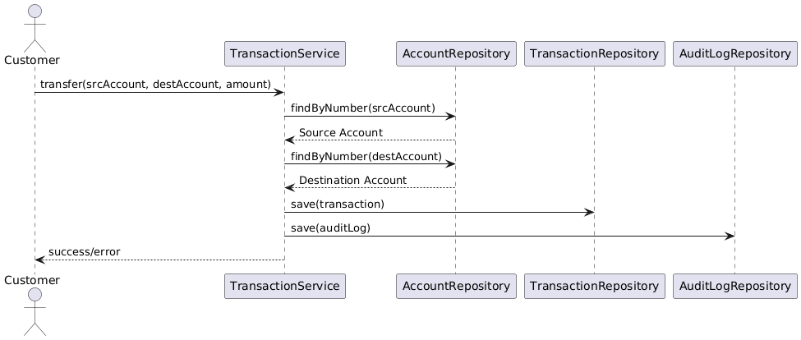

11. Transaction History Activity Diagram

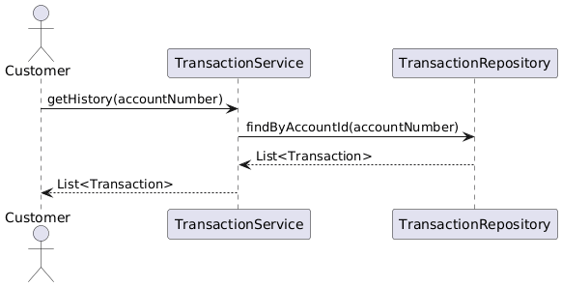

12.Close Account Activity Diagram

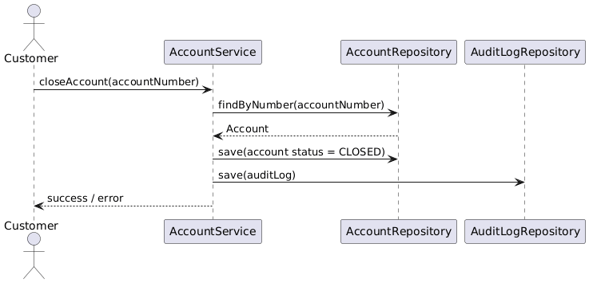

13.Change Password Activity Diagram

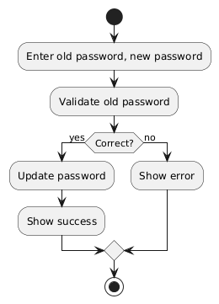

14. Register Sequence Diagram

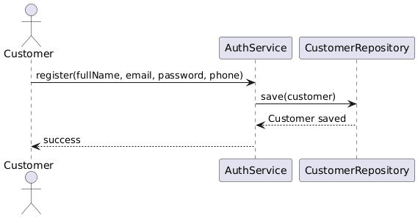

15. Login Sequence Diagram

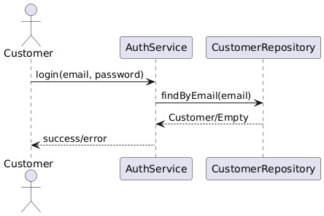

16.Create Account Sequence Diagram

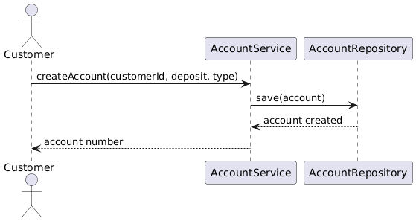

17. View Balance Sequence Diagram

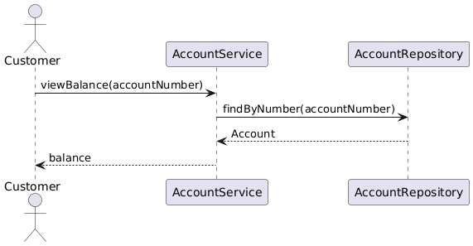

18. Withdraw Money Sequence Diagram

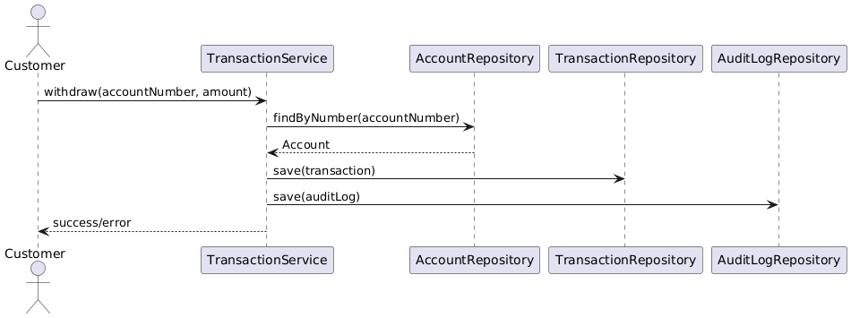

19. Deposit Money Sequence Diagram

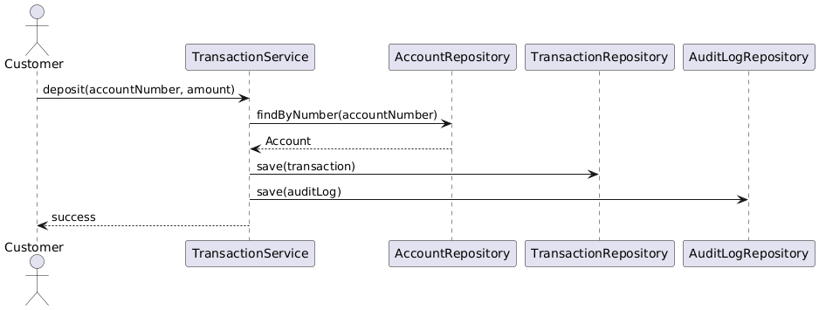

20. Transfer Money Sequence Diagram

21. Transaction History Sequence Diagram

22. Close Account Sequence Diagram

